OPTIMUS PRIME

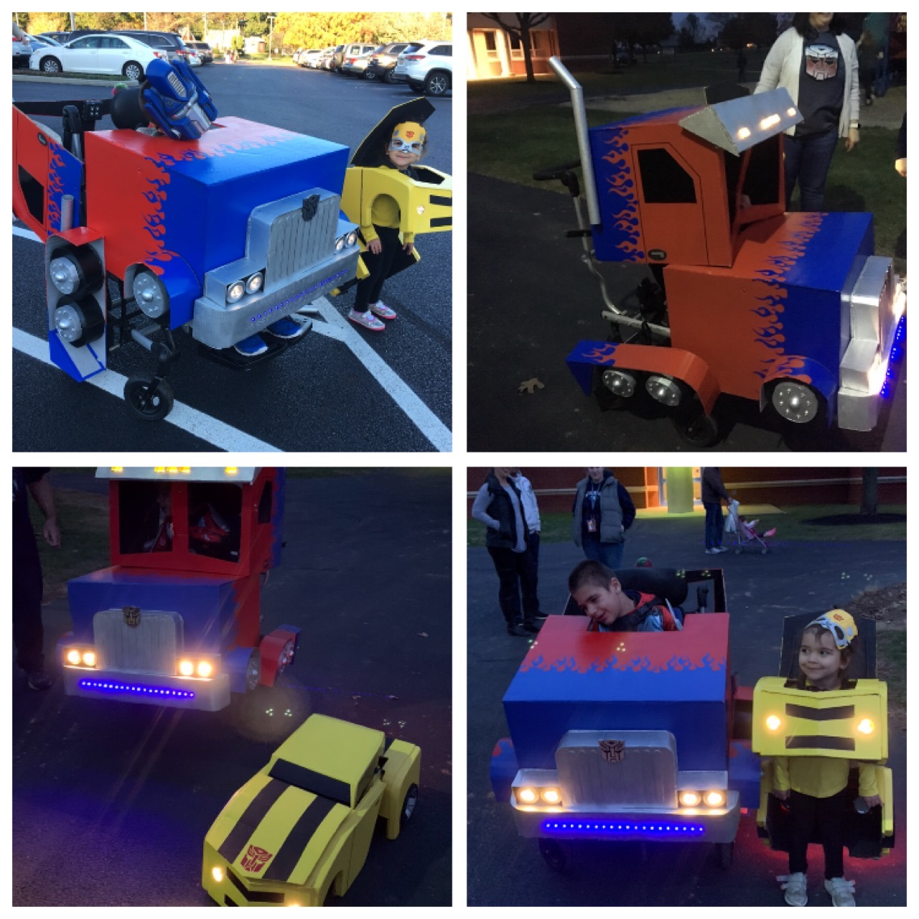
Drew from this instructional video, mostly for the artwork. https://youtu.be/H7oamD4tRIA
Three separate pieces: Cab, Engine Block, Rear Wheels

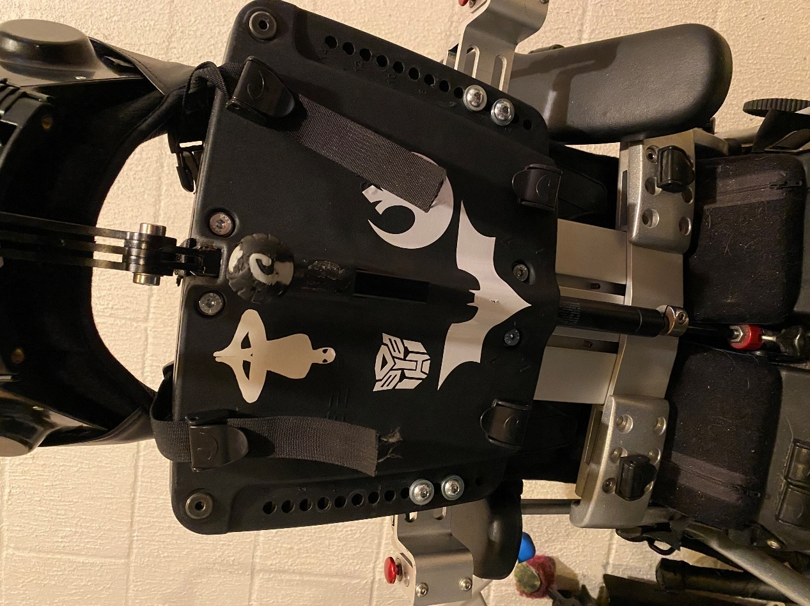
The cab was attached to the back of the chair which had holes in the back meant to mount additional equipment. Two large L brackets were attached, which where then used to attach the cab to the chair. The cab was then able to flip all the way back.

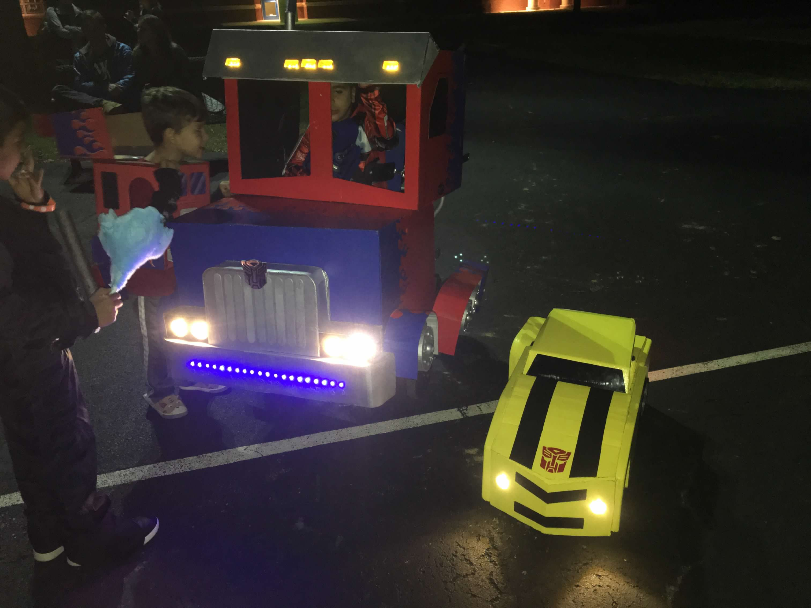
Blue lights on the bumper was a string of LEDs. Headlights were puck lights, and marker lights above the cab were marker lights used for the sides of trailers. I only used the covers, they were illuminated using a string of white LEDs. Bulbs in between the marker lights were covered with electrical tape to block out the light.

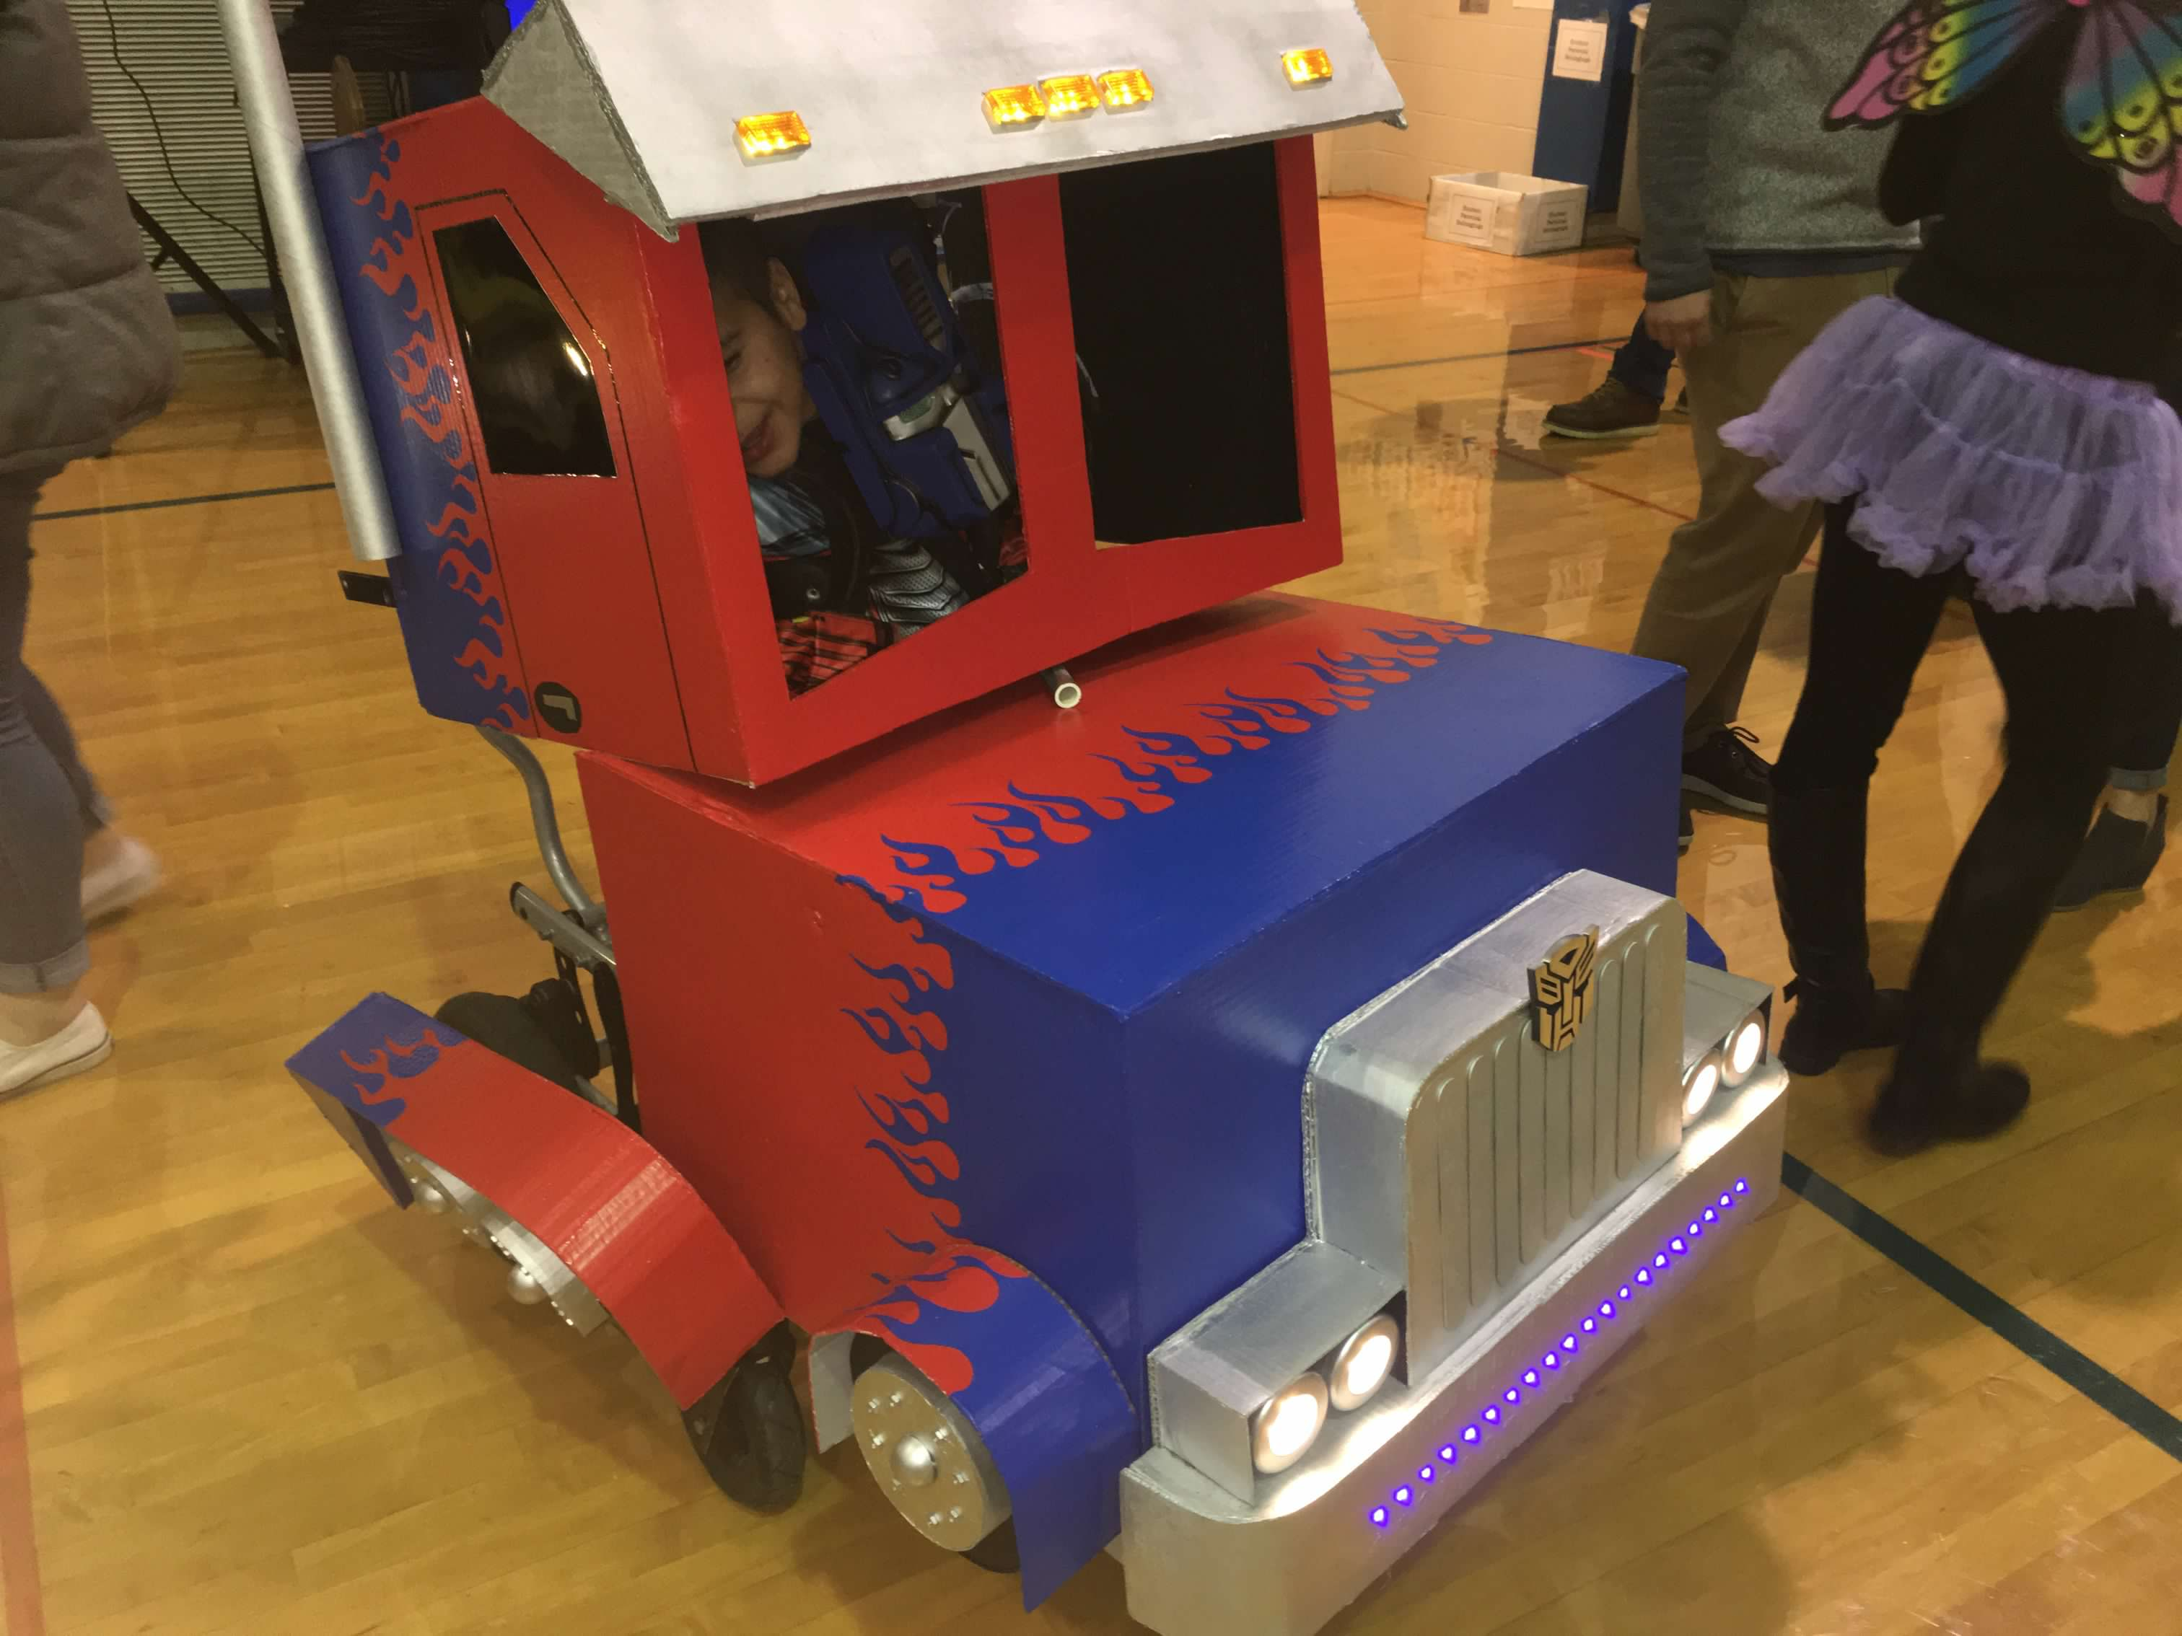
Entire body was made out of cardboard, and painted with interior house paint.
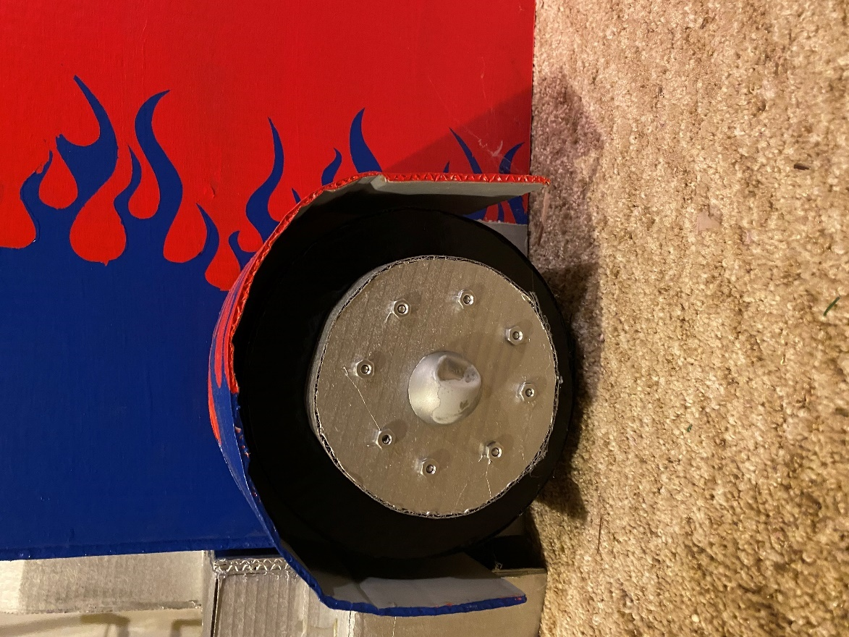
Wheel hubs used standard nuts for the lug nuts and a ping pong ball cut in half in the center.

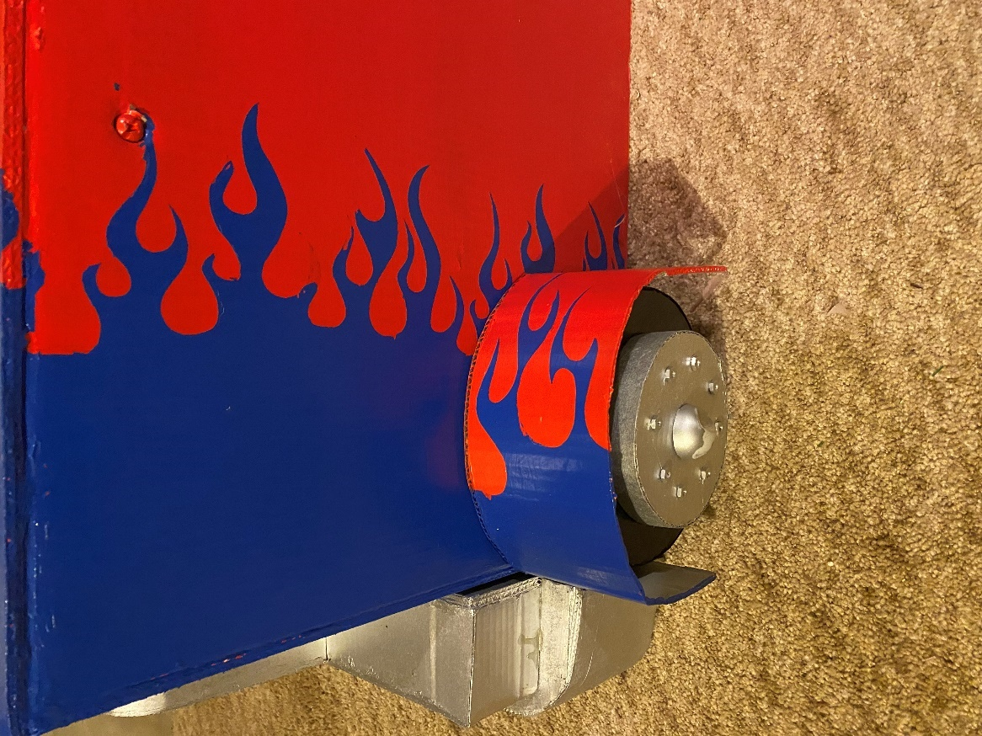
Flames were hand painted using lowtack shipping lables(see part 2 of youtube video: https://youtu.be/bkfCZ8C-6wo?t=771). Once flames were cut out, negative portion was used for the front flames, positive portion was used for the red flames.
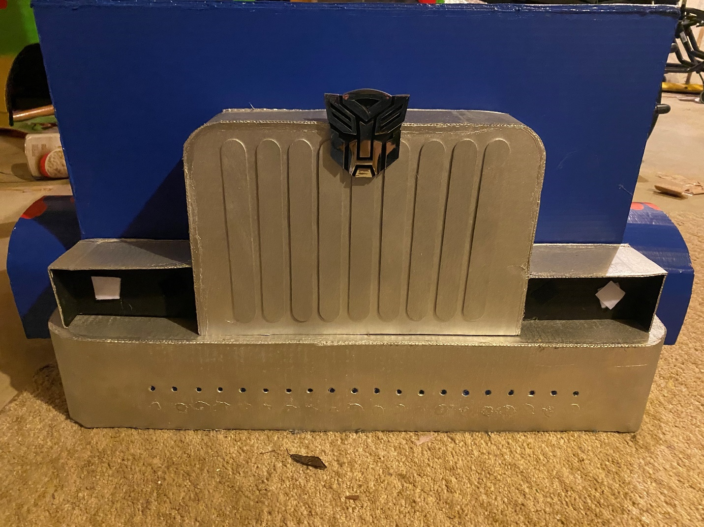
Grill is made from 1 Quart wooden paint stirrers, and an autoboots emblem found on Amazon.

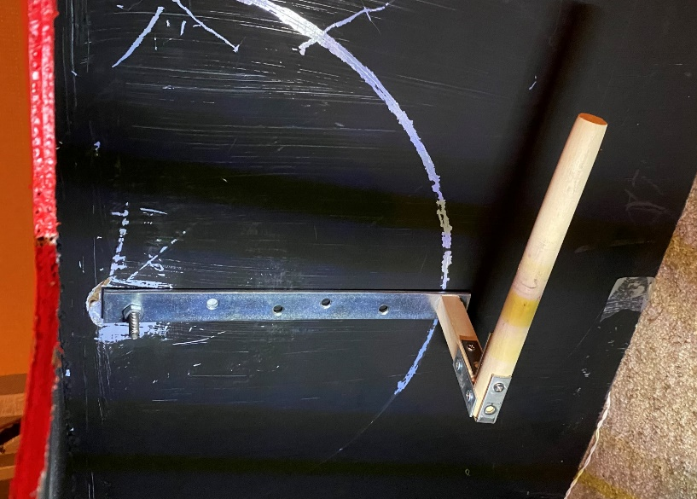
The engine block was then on a pivoting arm inside the costume. There are two dowels that fit into the holes where the tray would attach to the arms of the chair. Then the pivoting arm was attached to the dowels. In the down position, the engine block rested on the arms of the chair. When the engine block lifted up, the walls pressed against the arms of the chair and there was enough friction that it held in place. The first picture shows the Position of the arms when engine block is in the “down” position. The second picture shows the positions of the arms when the engine block is in the “up” position.

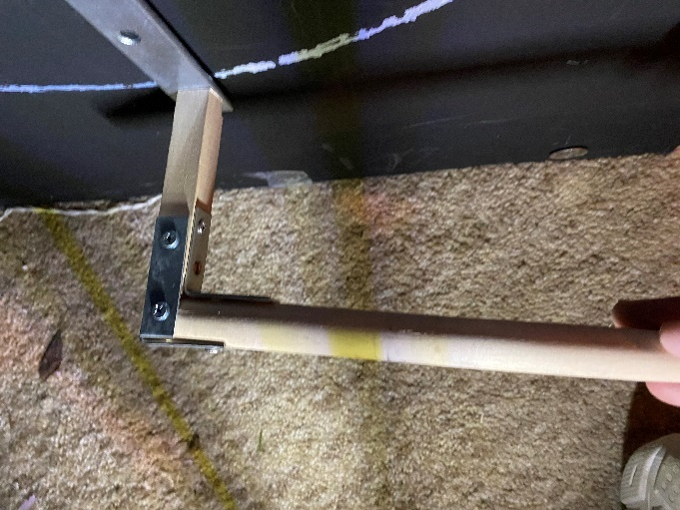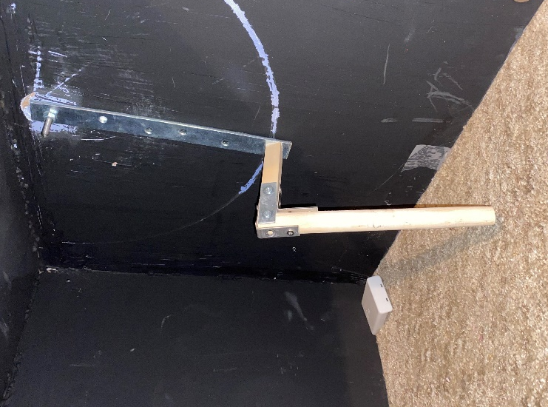
Mechanism was designed so that it rotated at both ends of the metal bracket. This way, the dowel would remain static and the cab could move up/back and down/forward during the transformation.

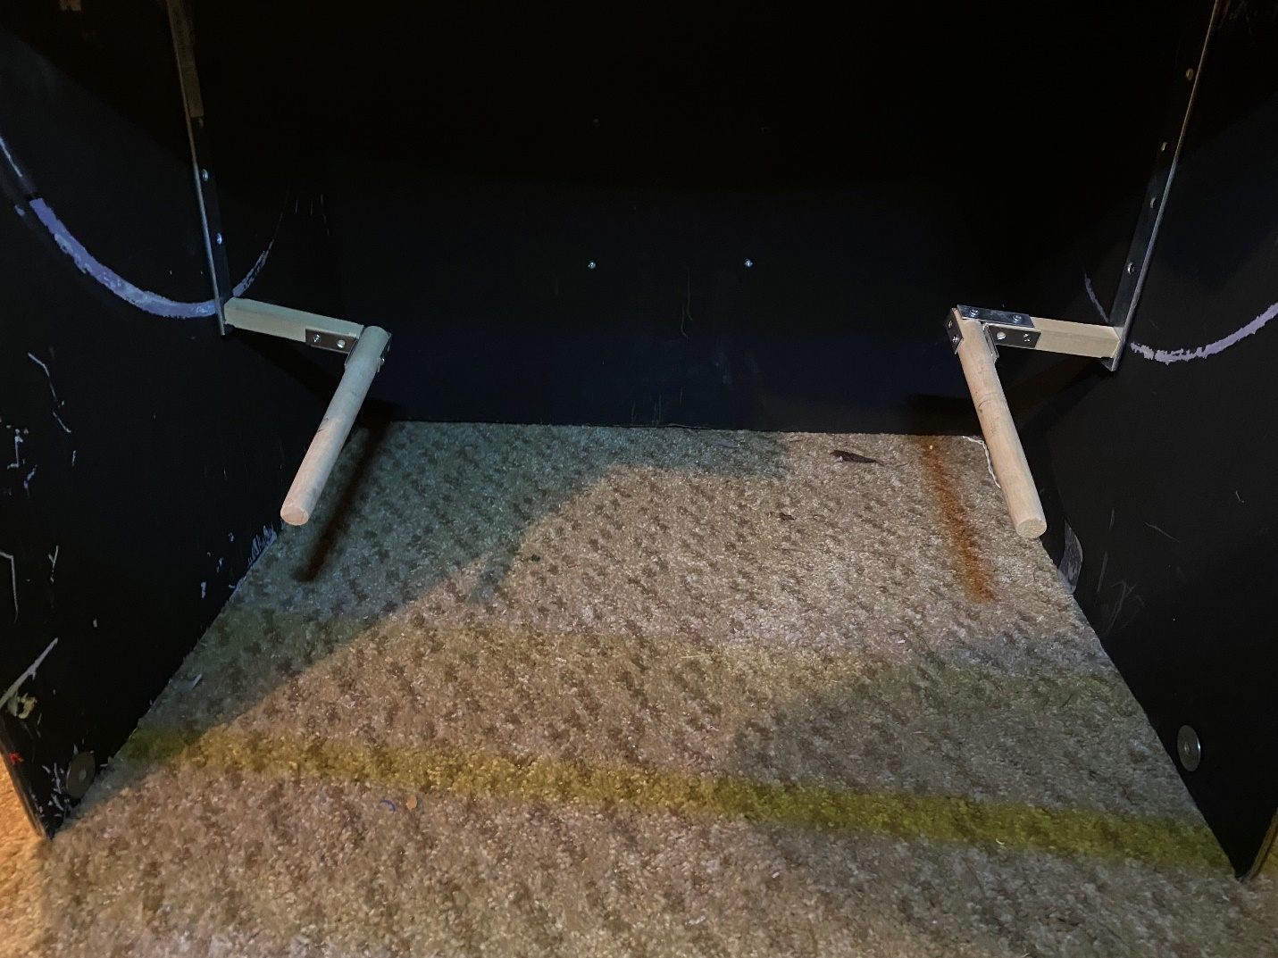
View of both arms from inside the engine block.
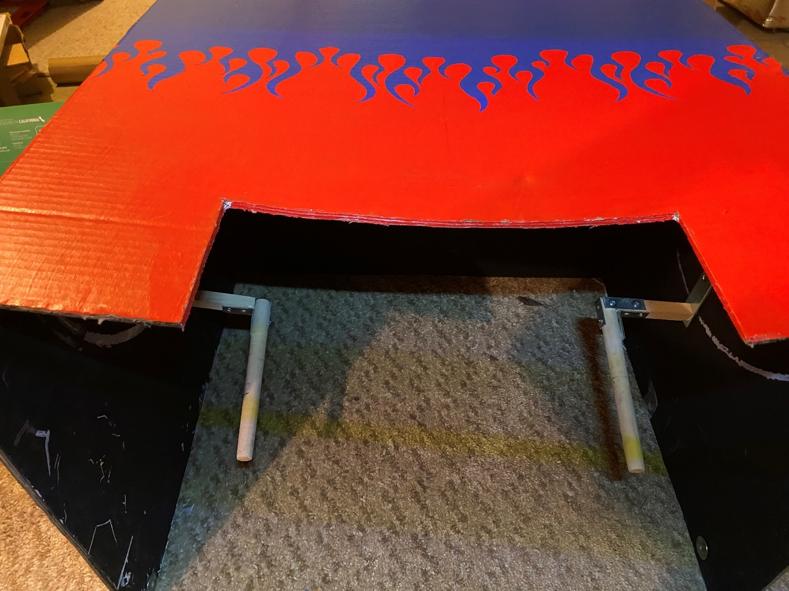
Alternate view of the inside of the cab. This would be as if looking at the costume when the engine block is in the up position.
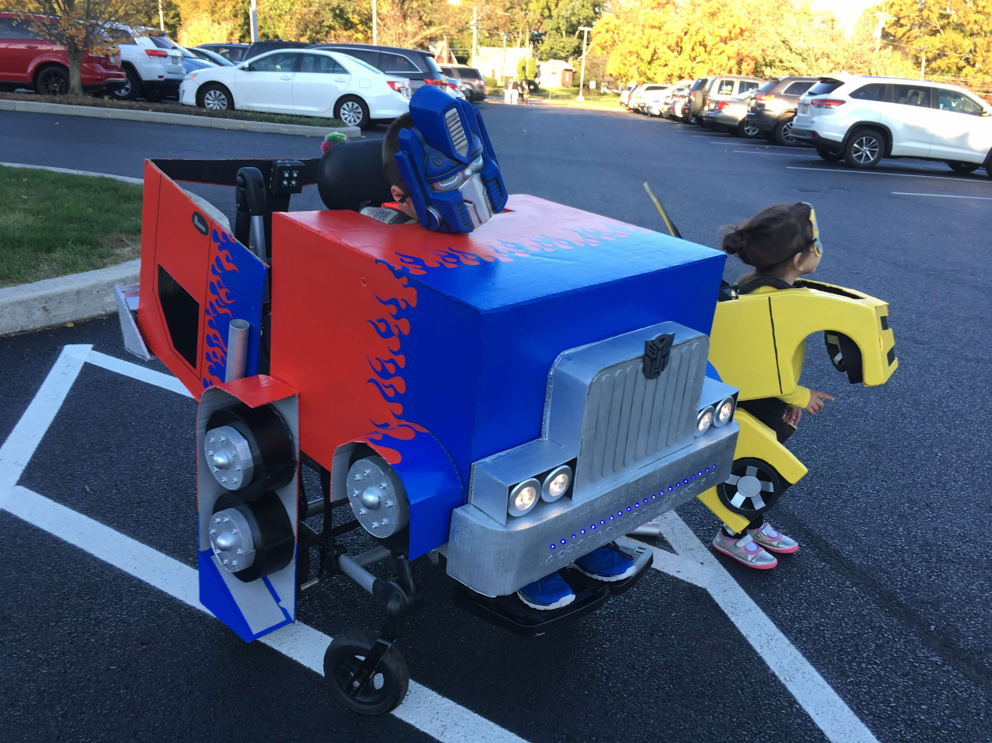
The wheels were attached to the back of the chair and also to the engine block, both with enough play so that they could pivot at both points. When the engine block lifted up, the Wheel wells became Optimus’ legs.

Components
Lots and lots of cardboard. Not the best building material, because it is not waterproof, but I do find that TV boxes work best because of their size and the carboard tends to be a sturdier material.
Paint
Marker Lights: https://www.autozone.com/exterior-lighting/side-marker-light/p/blazer-international-amber-led-rectangular-mini-clearance-light/87627_0_0
Puck Lights

We added a soundboard so that Alex could play some iconic sound effects – the “transforming” effect and the “scene switching” effect. Sound board was made using this programmable module:
https://www.electronics123.com/shop/usb5m-300-second-5-minutes-usb-recording-module-with-4-buttons-windows-10-7-compatible-5320#attr=4150,4151
Amazon List: https://www.amazon.com/hz/wishlist/ls/1WUX8HBL99W4W?ref=cm_sw_em_r_un_un_E2BcoJRJXdebd

