Jurassic Park Explorer
Much of this build came from this webpage https://www.jpmotorpool.com/reference/explorer/explorer_guide.php, where I had several reference photos and graphics to draw inspiration from.
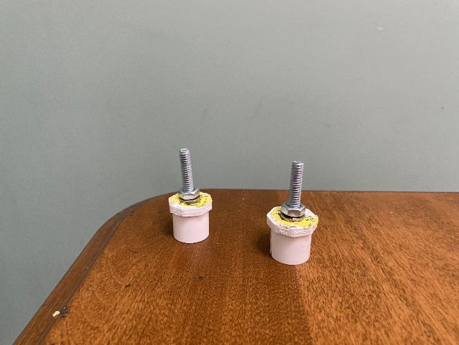 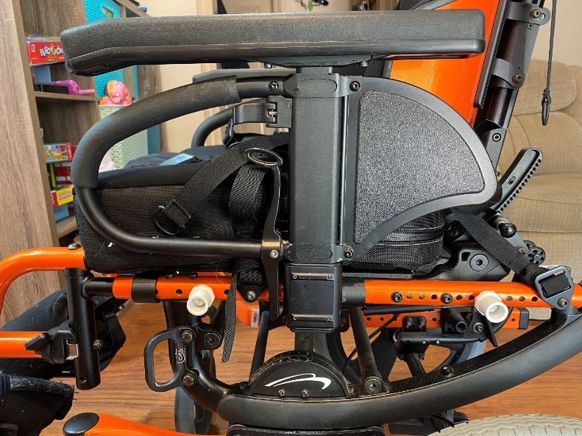To make the frame a bolt was drilled into a PVC plug and then fastened to the chair using pre existing holes.

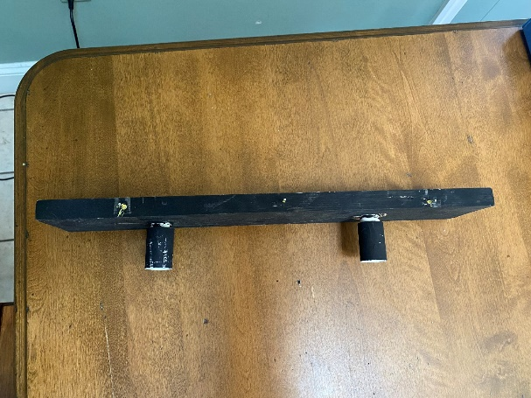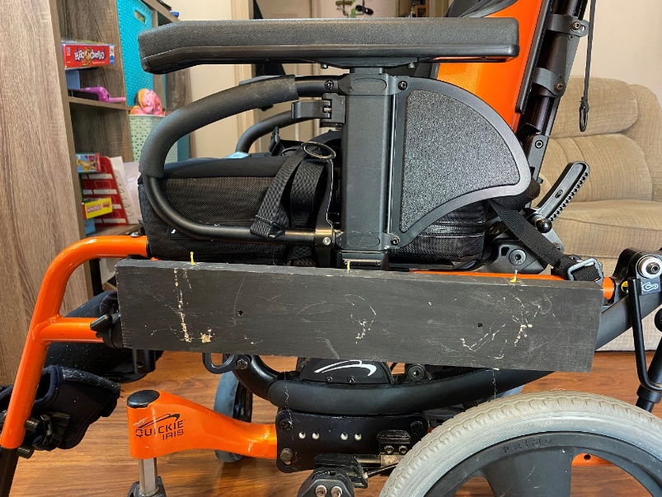
Two PVC couplers were attached to a piece of lumber to make the main part of the frame, and the couplers were easily attached to the plugs.

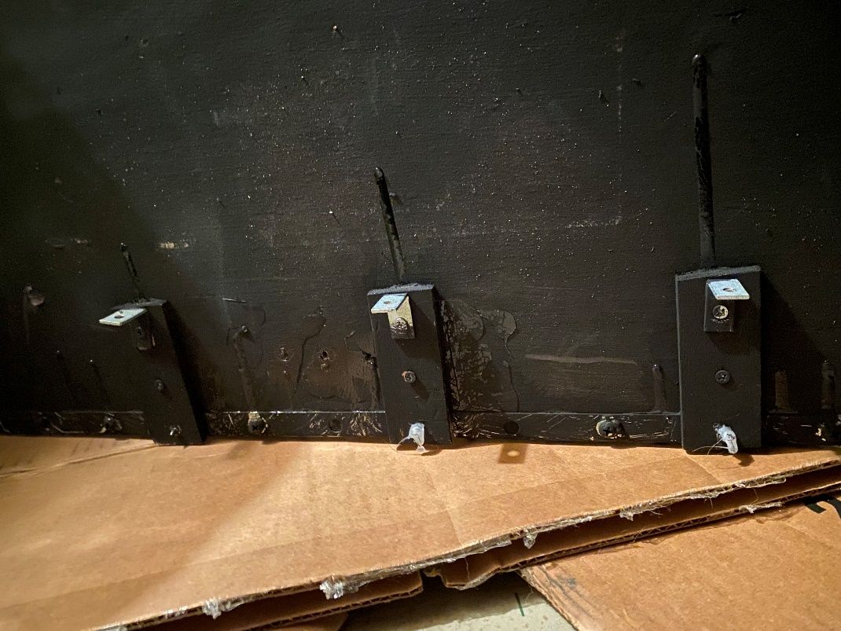
Corner braces were mounted directly to the costume and those rested on the frame

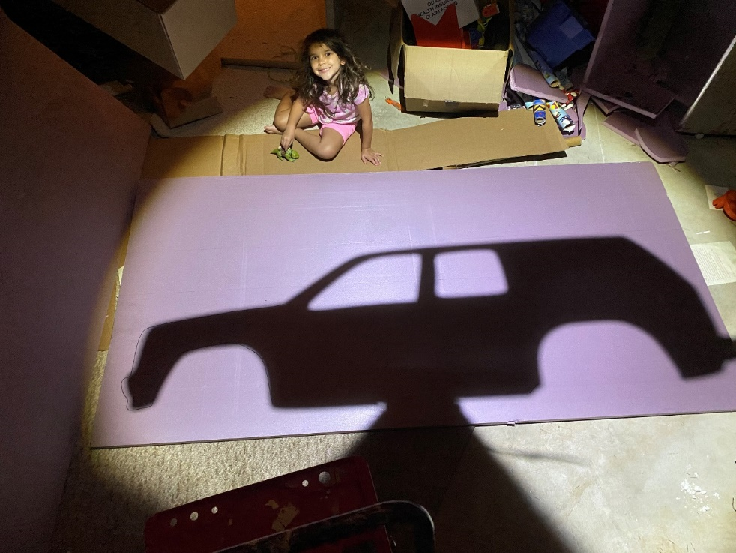
Sides were Foamular, I used Cricut to cut out a side profile of the vehicle and then used shadow casting to draw out the shape.

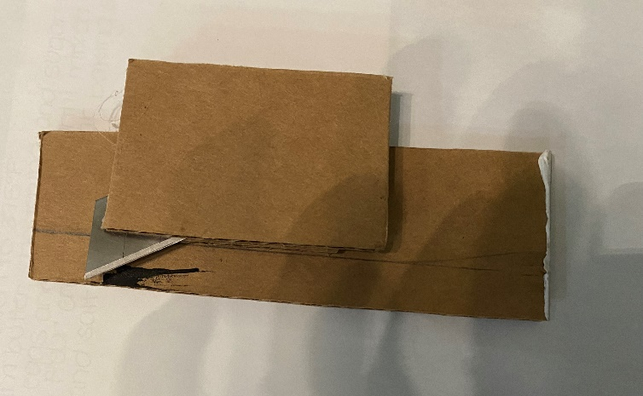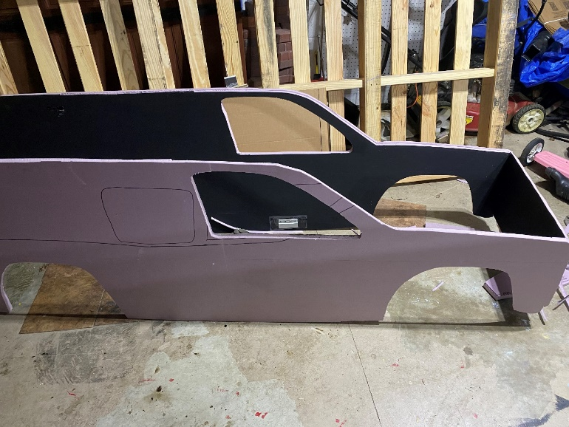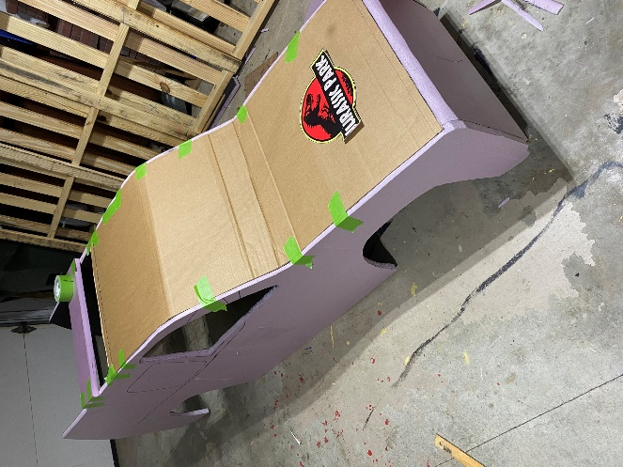
Hood and windshield were cardboard. In order for the cardboard to be flush with the foamular, I created a cutting tool that would cut a channel into the foamular. Any gaps or imprecise cuts were filled in with caulk. Used hotglue to bond all the pieces together.

Detail added to the body included cardboard to build out the wheel wells and a piece of crown molding along the body
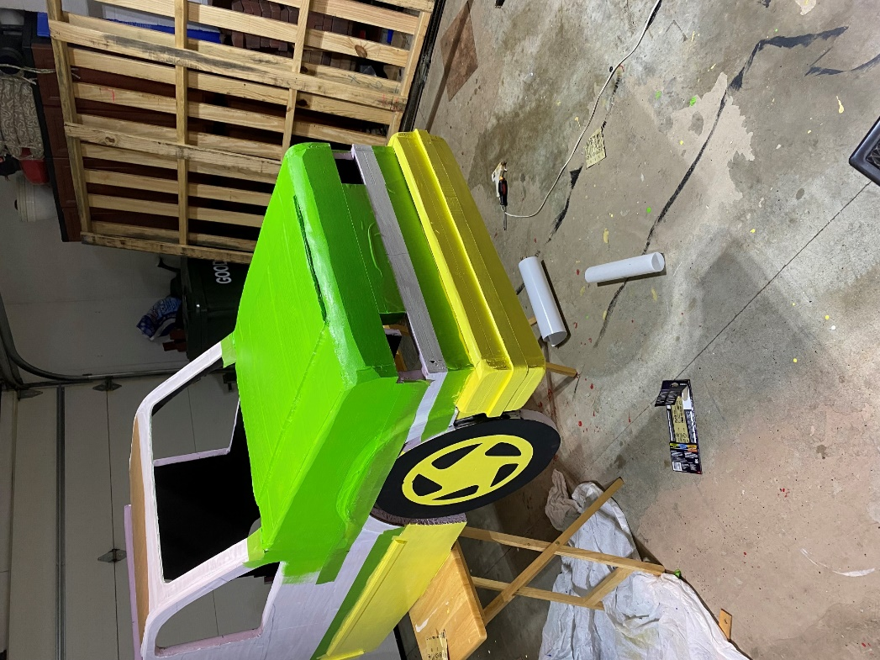
Painted with primer. Used the Home Depot Colormatch app on an existing picture, got three 8 oz samples of the colors needed

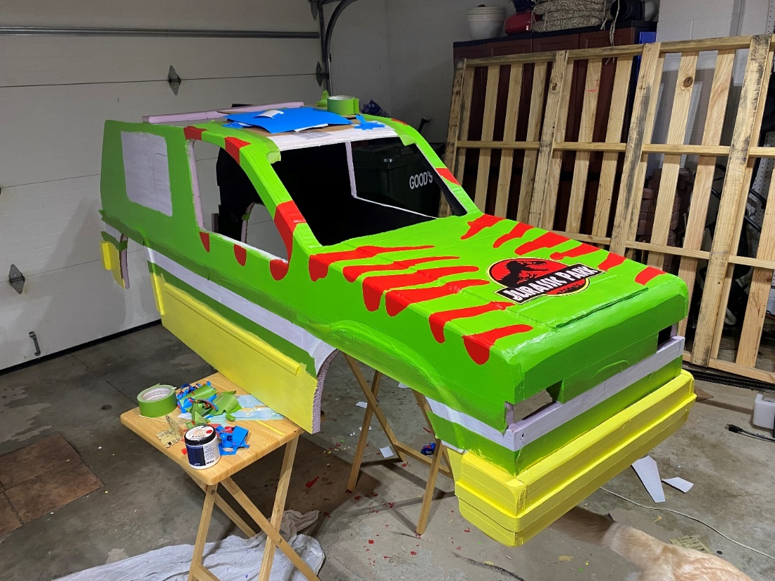
Used lowtack vinyl to block out the red stripes
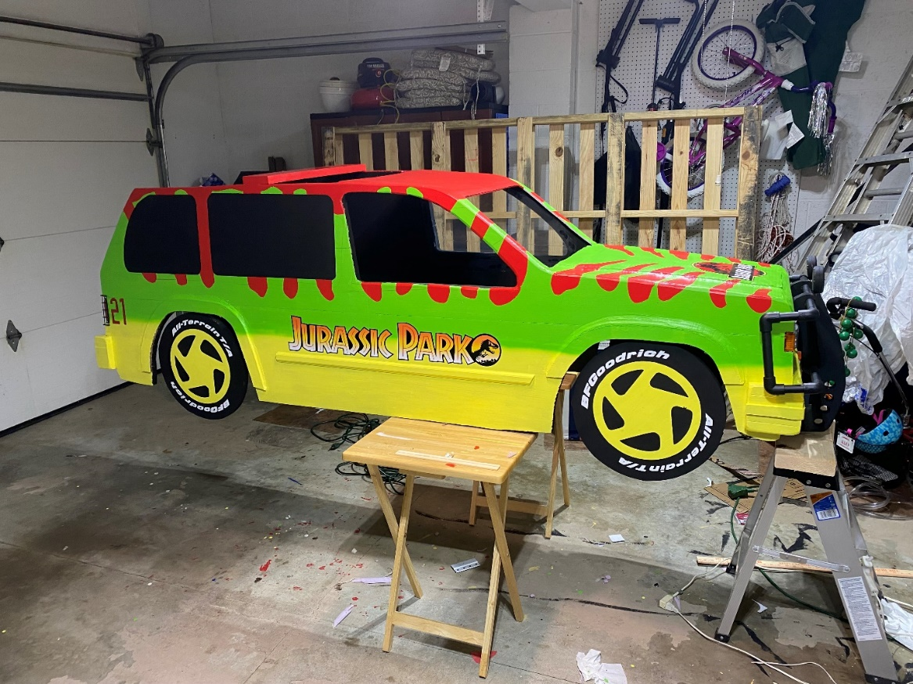
Used an airbrush to paint the green over the yellow

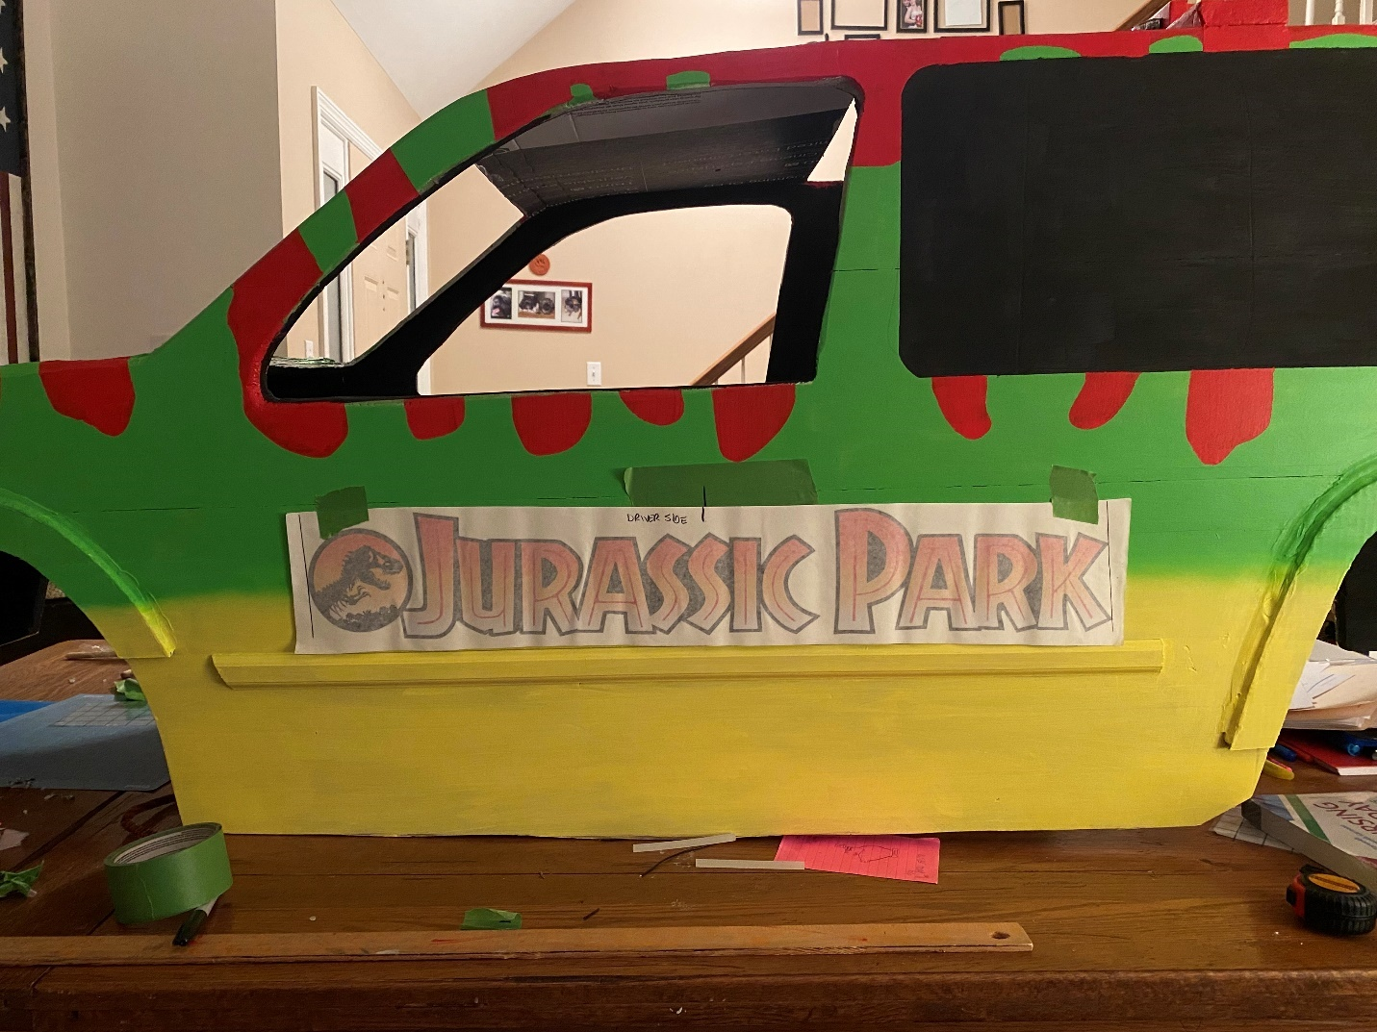
Scoured the internet looking for a vinyl decal of the Jurassic Park side panel large enough to fit the design. After several hours of no luck, reached out to a graphic design company who sold full scale decals to be used on Ford Explore replicas. Asked if he could print me a scaled down version, gave him the dimensions, negotiated a reasonable price and a week later I had the decals. Quality was intended for automotive use, so much higher than I needed but made the design turn out great.
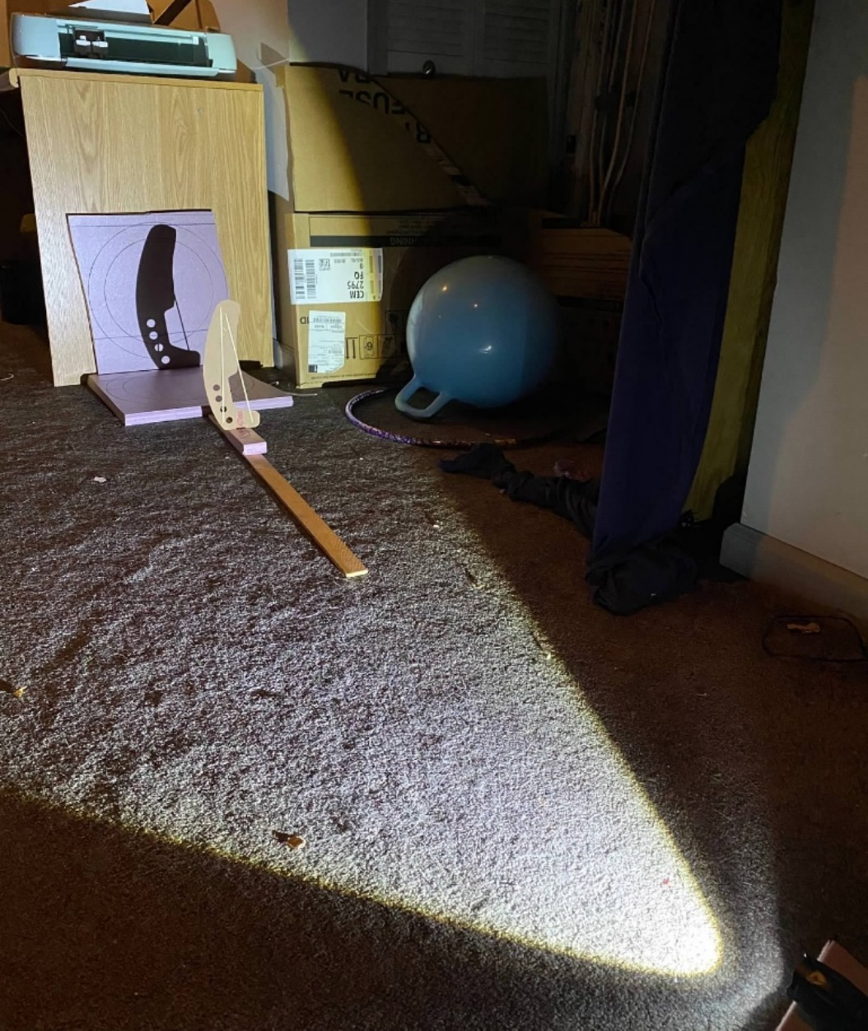
Brushguard was made with Foamular shadowcasting and ½ inch PVC.
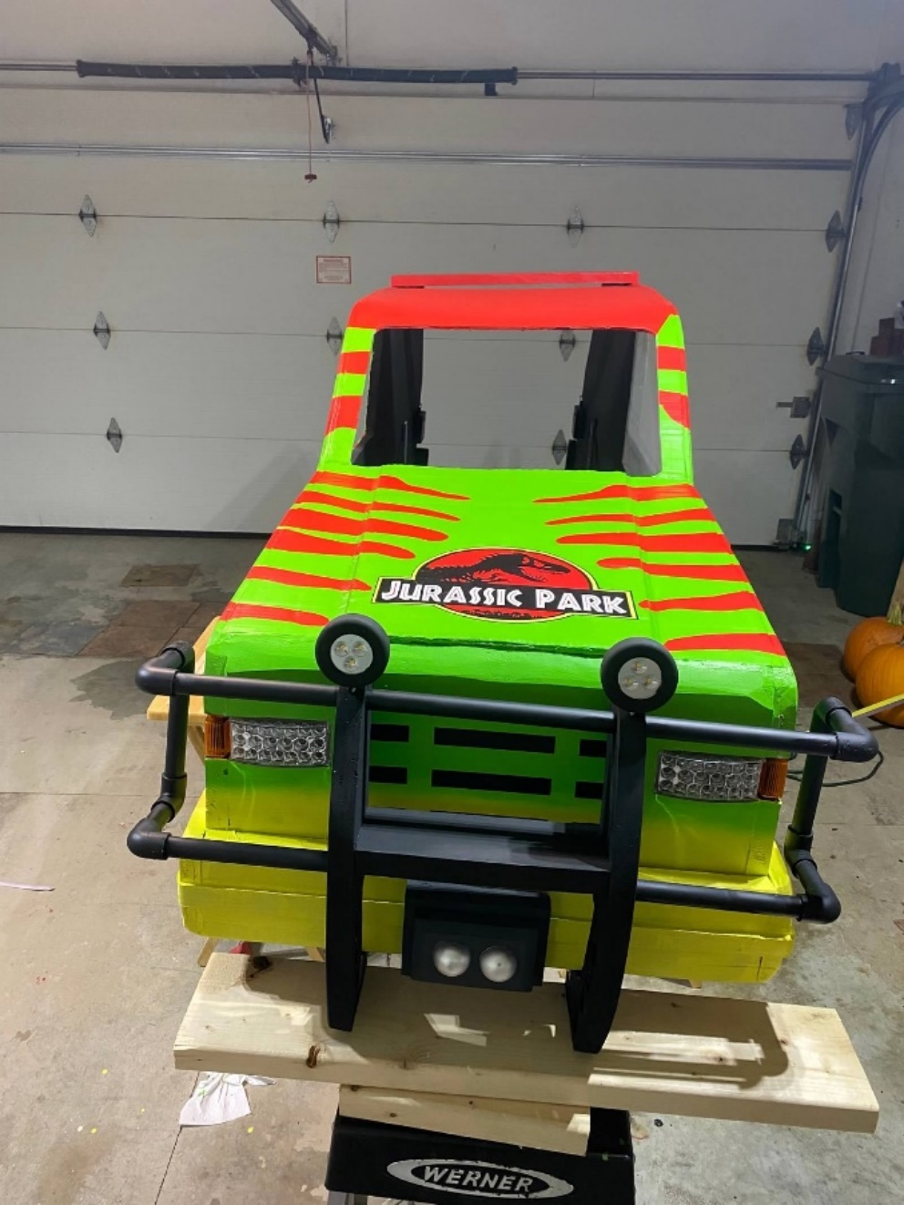
The GPS tracker is a ping pong ball cut in half and spray painted silver.

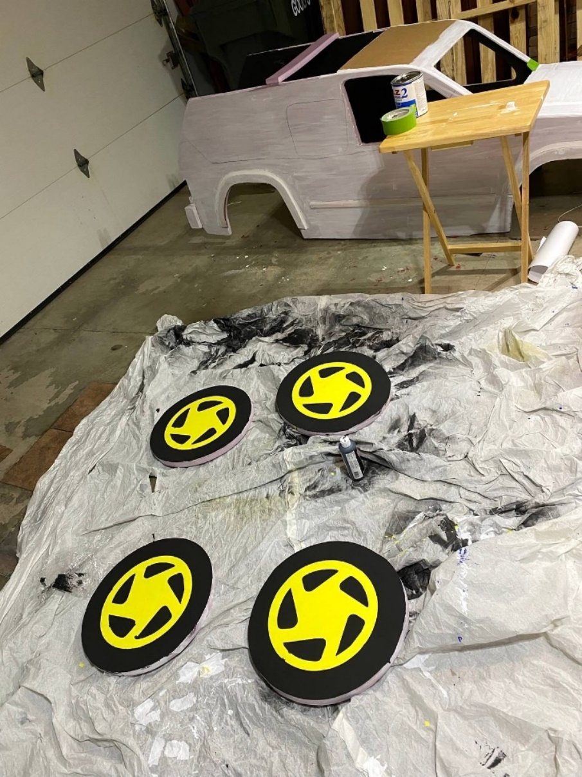
Wheels were cut and then painted. I uploaded a picture of the tire into Cricut Design Space, removed everything but the font, and cut it out. Gave the correct proportional curve.

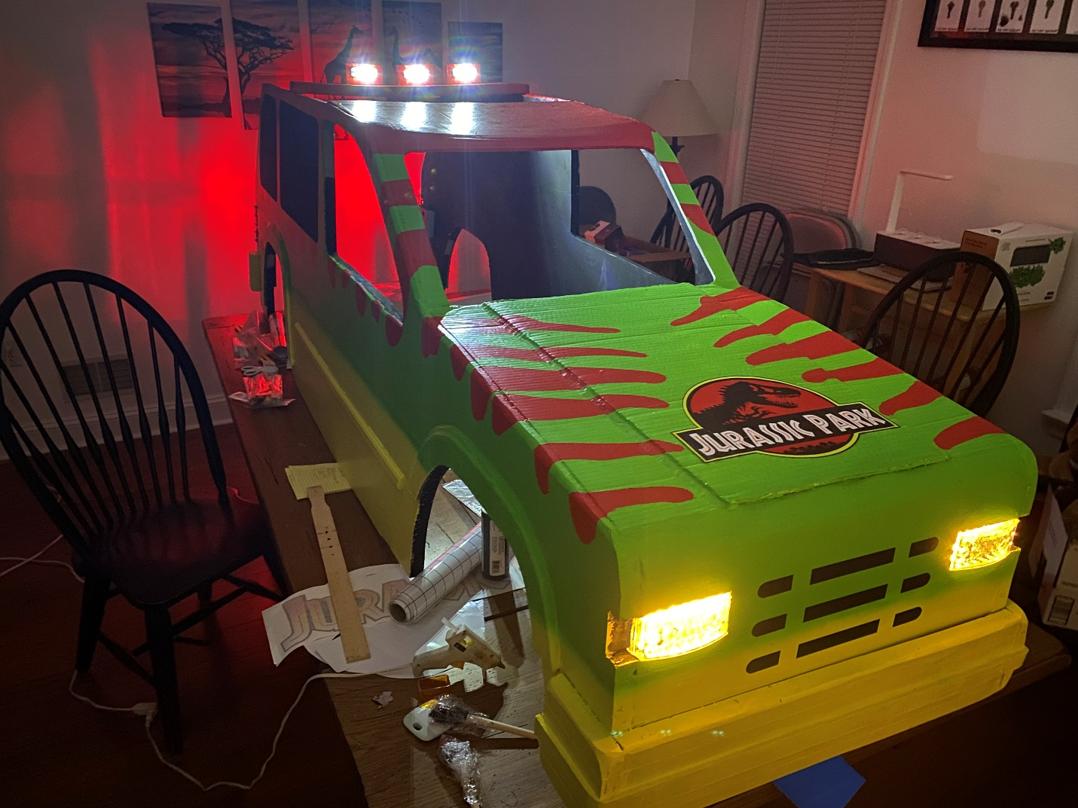For lighting, I used vehicle marker lights for the headlights, tail lights, and spotlights. I did not like the brightwhite light the headlights put off (those did not exist in 1994) so I instead replaced them with a string of warm white LED Christmas lights. I ended up drilling a series of holes in a piece of wood, but if I had to do this again I would just 3D print a board with the holes in it.
9V battery was also used on the spotlights. I had planned to wire them all together, but ran out of time and so wired each one to its own battery.

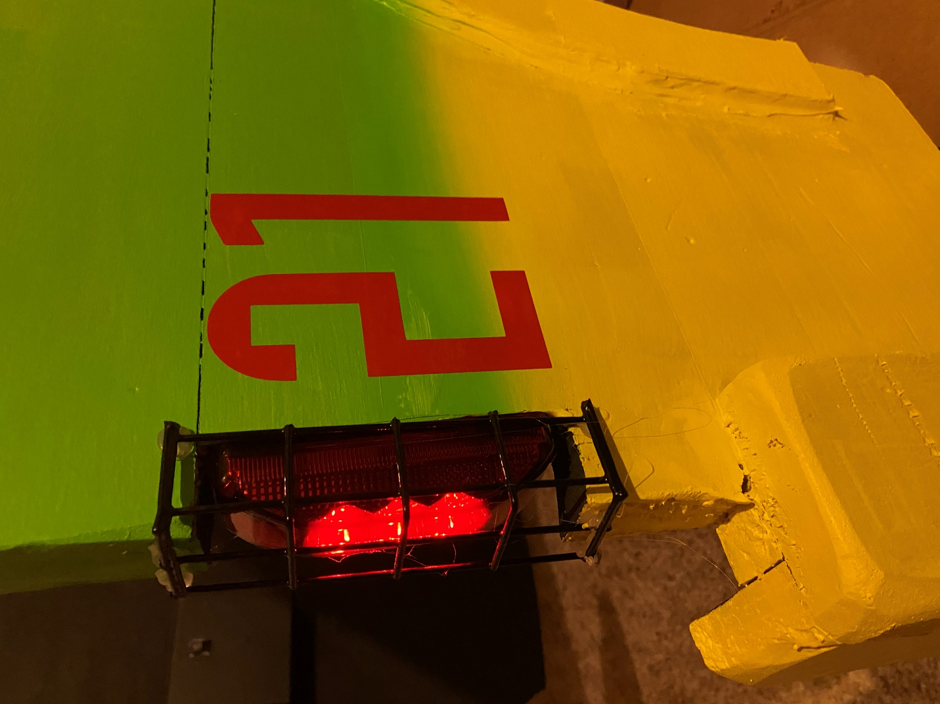
The taillights are rated as 12V for vehicle used, but I found that a 9V battery worked just fine. The cages for the taillights are Suet Cake Holders (brand new, never used, of course) that happened to be just the right dimensions and looked great.

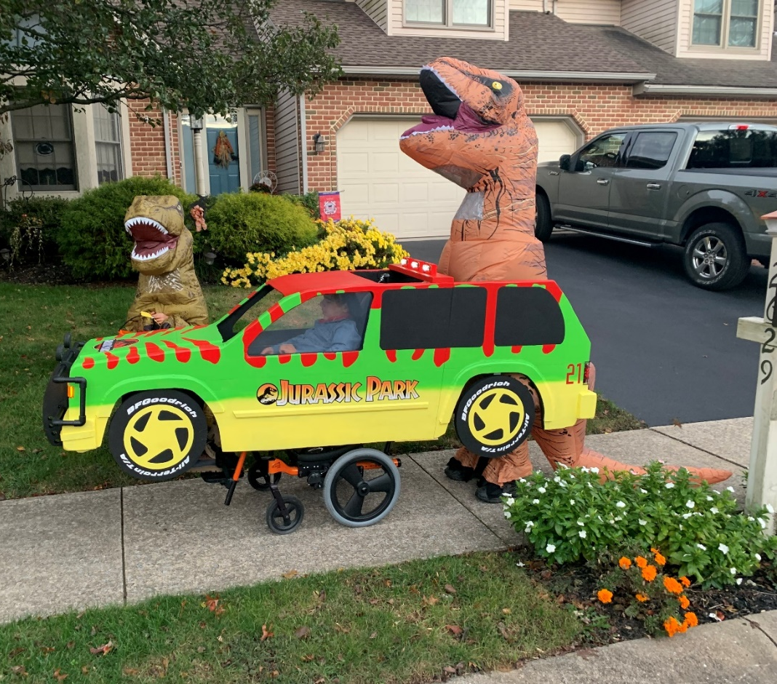
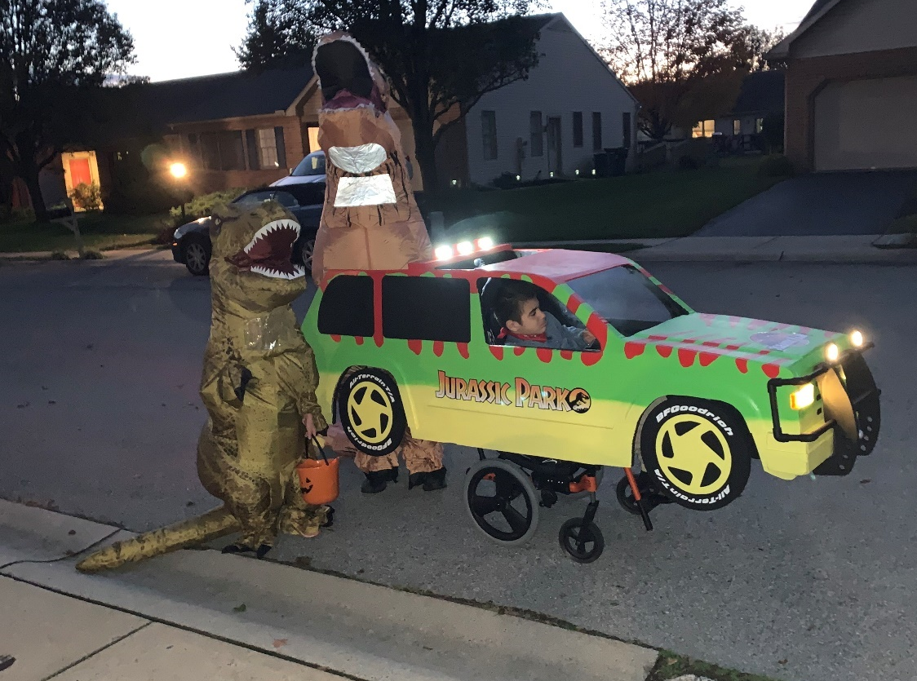

Parts List:
https://www.amazon.com/hz/wishlist/ls/3GBCSKH8WT9NA?ref=cm_sw_em_r_un_un_XGYmDbefJFSB1
Puck lights
Tail lights
Suet Cake Holder
Spotlights
Marker lights
Paint
Lowtack vinyl

