This costume was based off of another typical costume build. The creator put a tutorial online but I unfortunately can no longer find it.
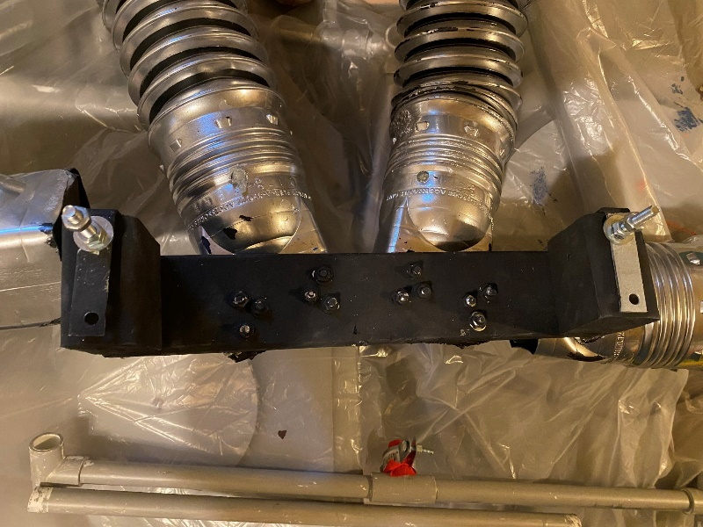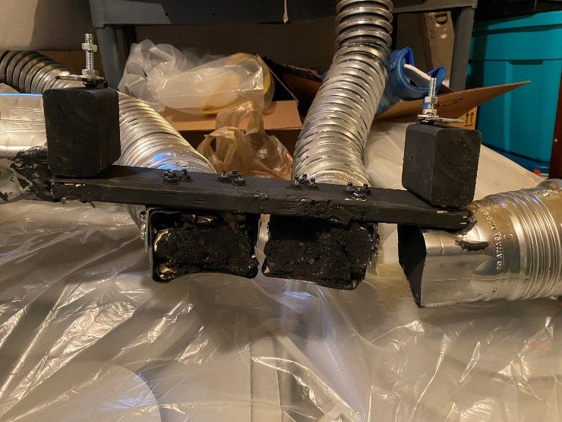
A brace was constructed that attached to the back of the chair. 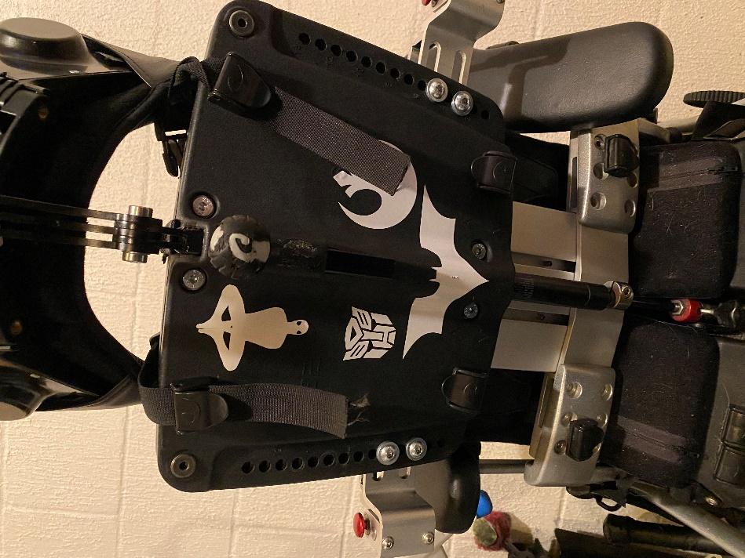
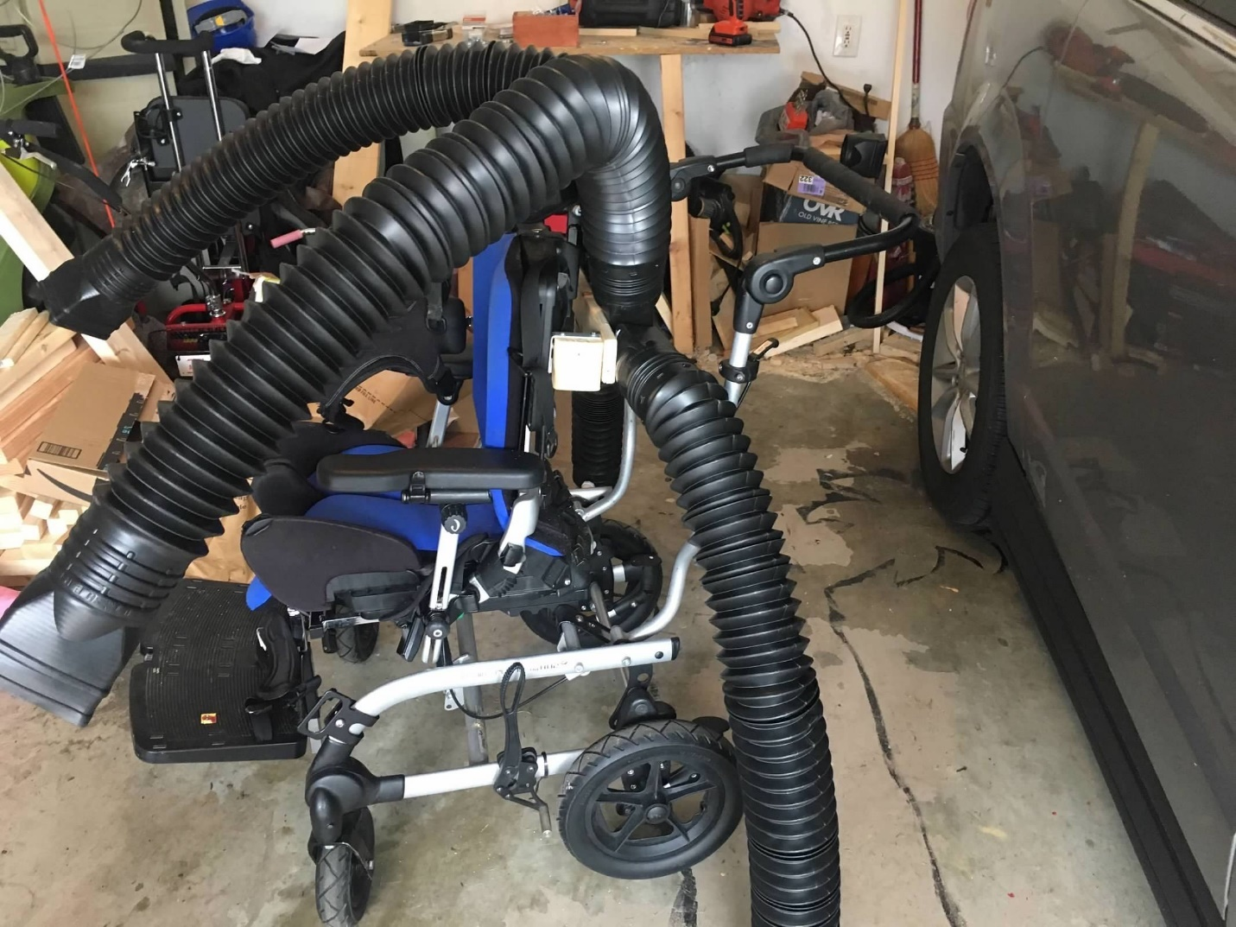
All four arms were attached to that using brackets. This photo is in the early design stages, reinforcement had not been added to the top arms.

The arms were six foot downspouts extensions. I cut the one end off and spraypainted silver.

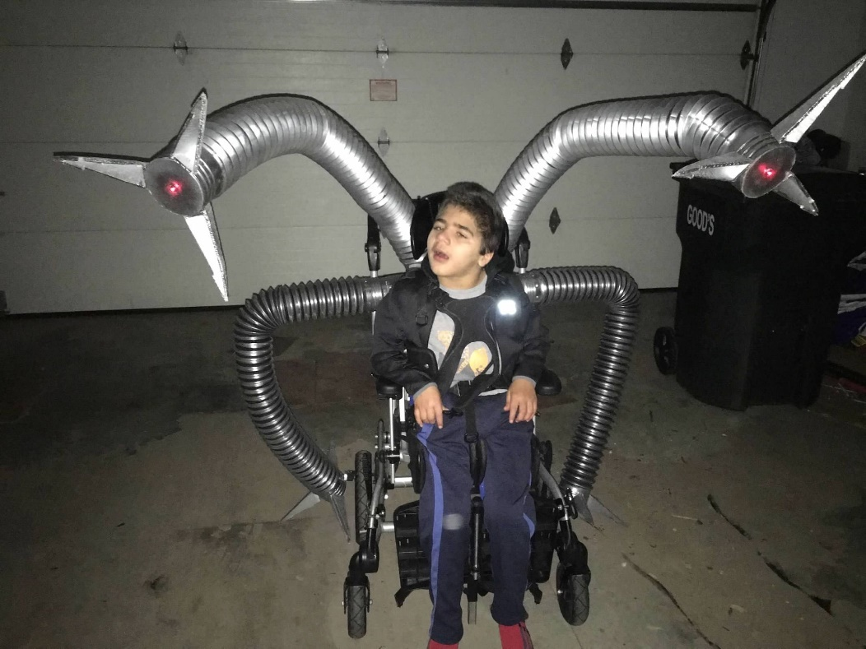
The two upper arms were reinforced with heavy gauge cooper wire and sprayfoam. The lower arms, because they would be mobile, were empty with no reinforcement

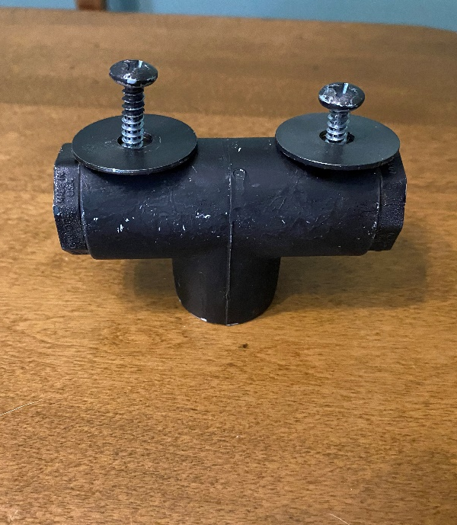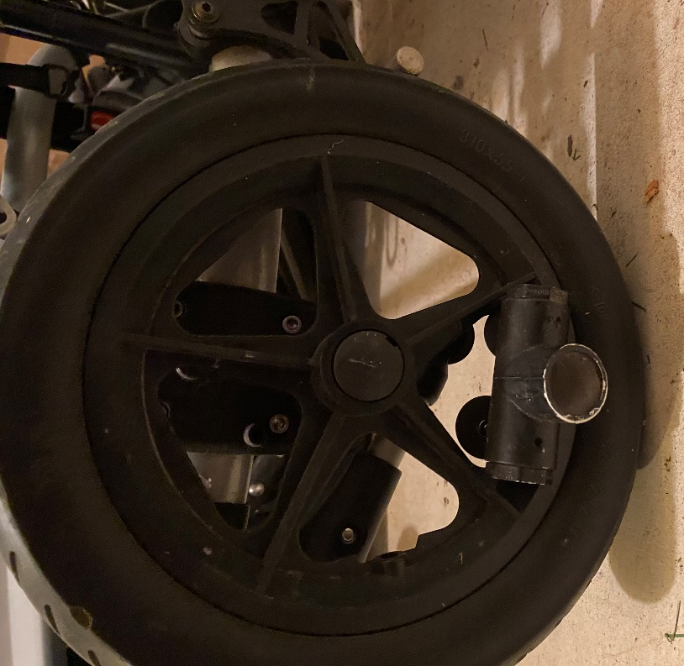
To make the lower arms move, a ¾ Tee with screws and fender washers was attached to the wheels off of center.
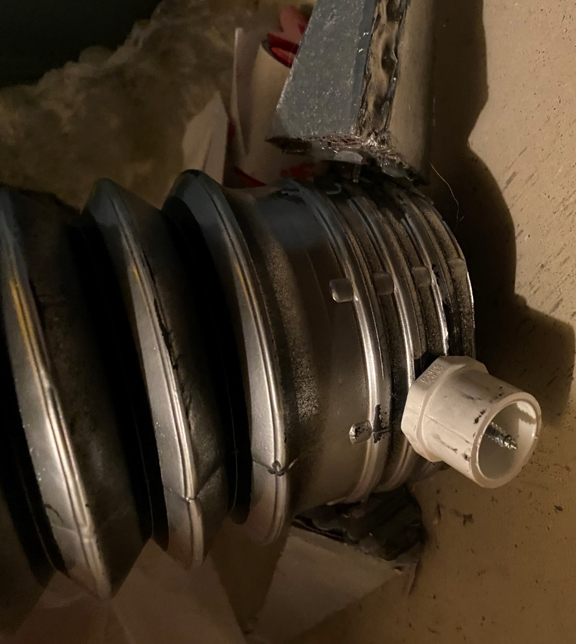
A ½ plug was attached to the bottom of the arms. Plug then attached to the Tee.
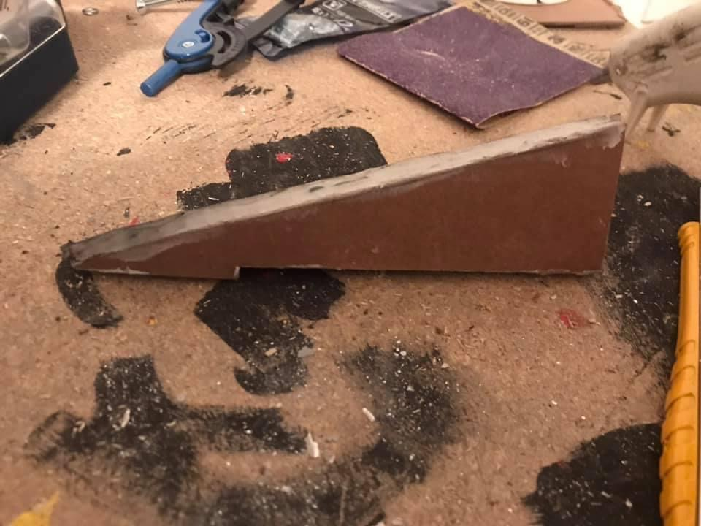
Beaks were made out of carboard by tracing the stand from an artificial Christmas tree
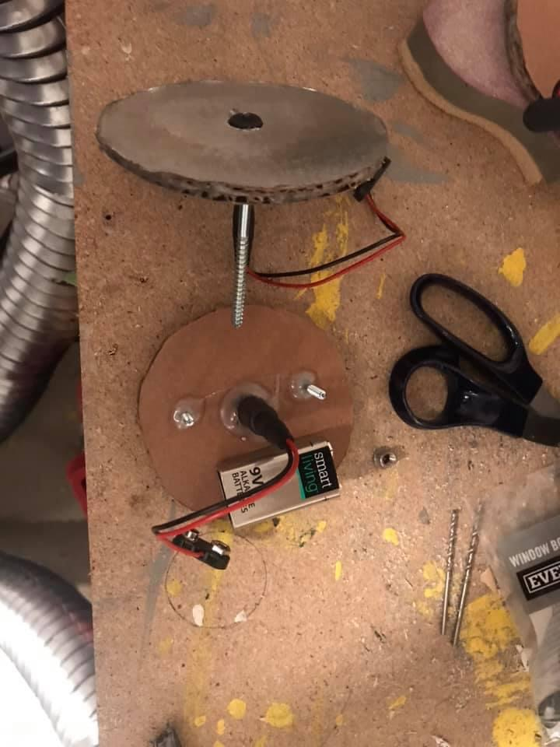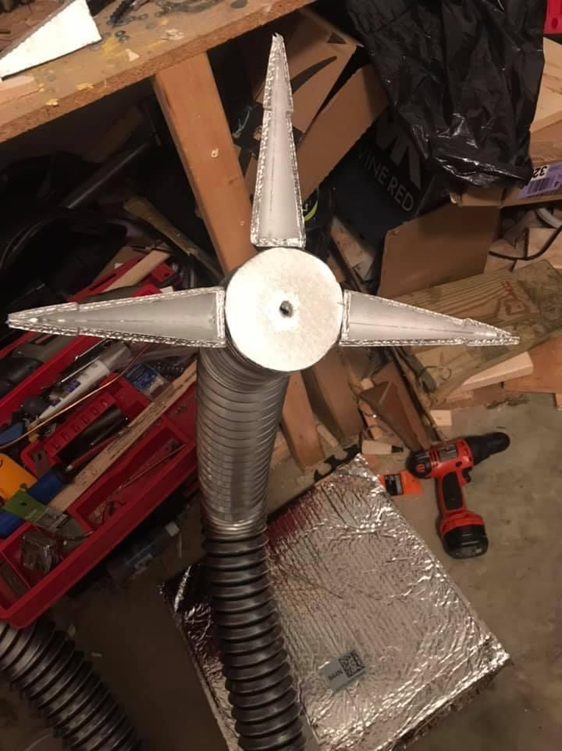
Lights were LEDs powered by 9v batteries

